**DITHERING AND HALFTONING**

How to print a grayscale image?

Printers do not produce shades of gray but take ink and apply it as splotches on paper.

Dithering:

Add some random noise to the image before quantizing it.

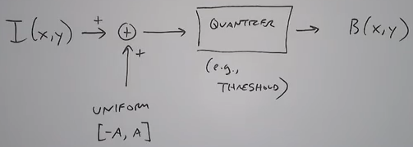

A gray scale image having a gradient when quantized to 2 bits yields:

 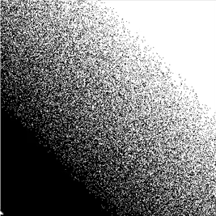

Halftoning:

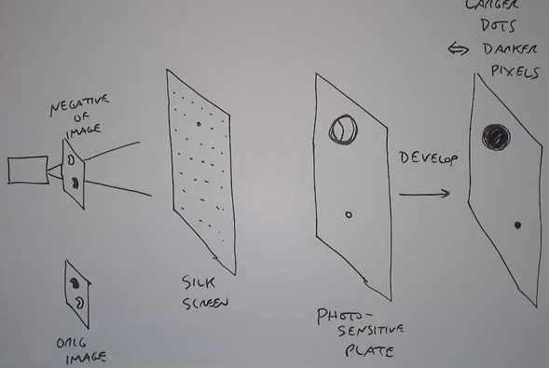

Digital Halftoning:

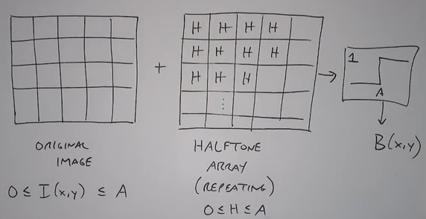

Let us consider the following 5 x 5 matrix block to be a candidate for H:

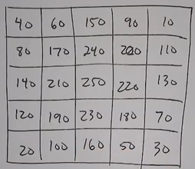

Observe the pattern of values in this block. It has high values in the center and as we spiral outwards, the values decrease. Moreover, all the values are a multiple of 10.

But how does this ‘H’ turn image to black and white dots?

Suppose we have a constant intensity of 50. So 50 would be added to each of the values in matrix ‘H’. And those going above 255 would be turned to white. The others would be black. We would get: 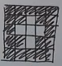.

Now suppose we have a constant intensity of 140. So everything lower than 110 remains black while others are white: 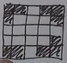.

Smaple image:

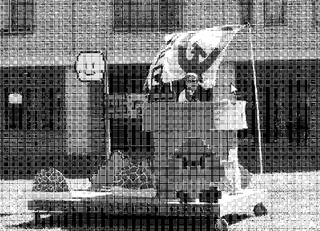

*Perceptual quality*:

* Halftone matrix size
* Matrix dot shape
* Matrix angle

Image can be blocked diagonally like:

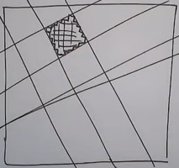

In printing also we could tessellate with non-square tiles (works in color-toning).

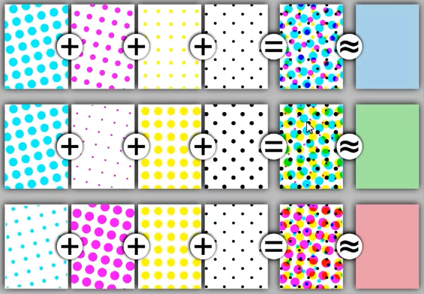

CMY channels are each tilted at a different angle and added with diagonal channel having black dots so that human eye perceives it as a color.

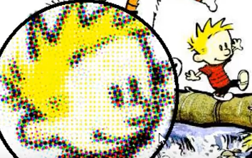

Scenario for displaying multicolored images on screens that have only 16 colors:

Using the alternate half tone matrix (H):

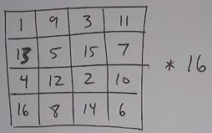

16 to get maximum color value of 256 (range 0 - 256).

This actually maximizes the distances between the dots that go on => crosshatch effect rather than a blob effect.

Result of alternate H on a gradient image:

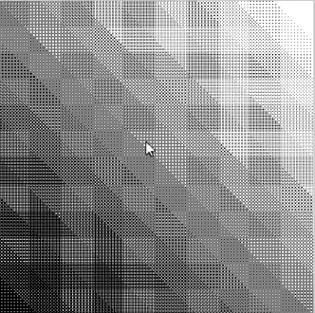

***Error Diffusion Dithering***: